Environment:

Node: 14.16.1

Yarn: 1.22.5

1. Test documentation  
   Command: yarn test:watch

It will automatically test all the test cases.

* Loading 10 car data from the server.
* Show/hide car availability.

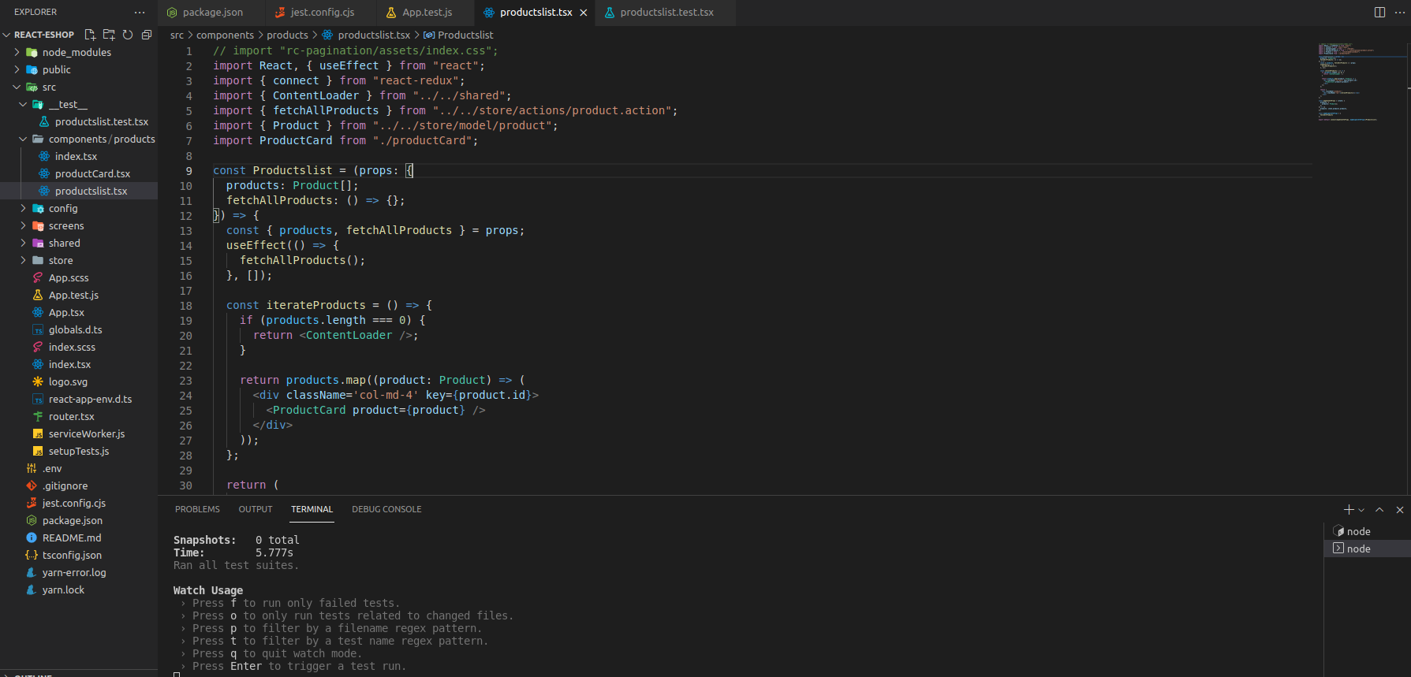

1. Description for front-end  
   It loads images and required information from the database at the first loading.

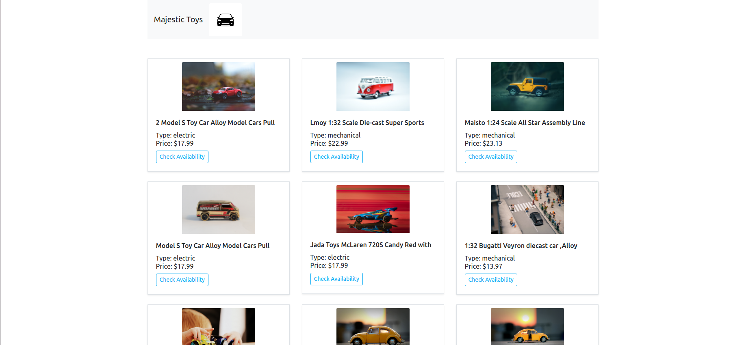

And if you click check availability button, it will show availability of each product.

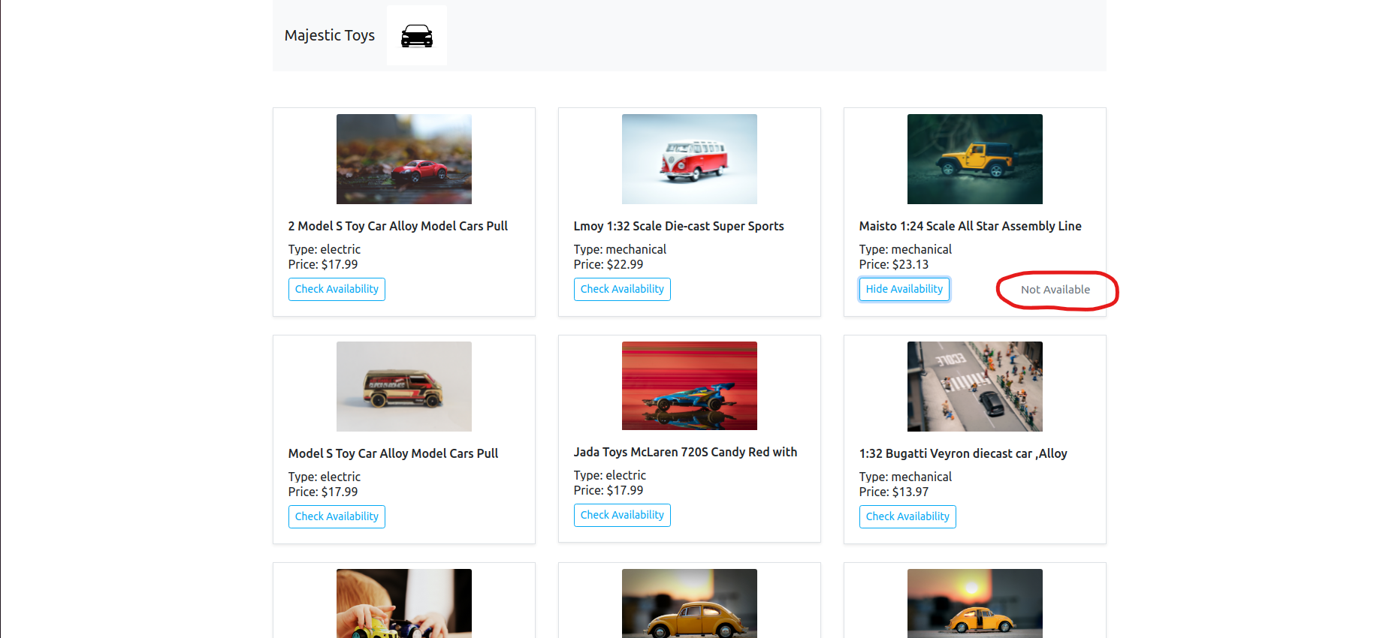

1. Deploy REST API

This is a simple rest api which was created by using CodeIgniter 3.

So you only need to deploy it apache service.

Also database file was attached for this work.

There’s only one table for this database.

